**Faculty Loading System**

Project Professor

|  |  |  |
| --- | --- | --- |
| Name | Position | Email |
| **Mr. Manuel Sanchez** | Professor | manuels@apc.edu.ph |

Project Advisers

|  |  |  |
| --- | --- | --- |
| Name | Position | Email |
| **Ms. Rhea Valbuena** | Adviser | rhear@apc.edu.ph |
| **Mr. Jojo Castillo** | Subject Matter Expert | jojoc@apc.edu.ph |
| **Mr. Eric Salalima** | Subject Matter Expert | erics@apc.edu.ph |

Project Team

|  |  |  |
| --- | --- | --- |
| Name | Position | Email |
| **Rafael Ochotorena** | Project Manager | raochotorena@student.apc.edu.ph |
| **Louise Gabrielle Lazaro** | Project Manager/Researcher | ldlazaro@student.apc.edu.ph |
| **Von Matthew Alfafara** | Project Analyst/Designer | vsalfafara@student.apc.edu.ph |
| **Allen Baldovino** | Project Analyst/Designer | aabaldovino@student.apc.edu.ph |
| **Jameiah Nicole Jauod** | Project Analyst/Researcher | jgjauod@student.apc.edu.ph |

1. Introduction
   1. Background of the Problem

The administrator/s of the SoCIT department needs to have an automated faculty loading module. As of now, there is a tedious manual process of scheduling teaching assignment caused by careful consideration of a number of factors (constraints) such as, matching the course offerings with the faculty member who can teach the course (based from specified faculty qualification and expertise). Based on our research, there are 80 SoCIT serviced courses per term matched to about 22 faculty (both fulltime and part-time). The tedious manual process also consists of: matching the teaching schedule of faculty with course schedule, matching the schedule of faculty and course with room or lab availability, providing a teaching load within the required teaching unit of the faculty, and institutional policy of no more than 2 consecutive classes or 3 classes per day. Because it is manual, there are times that human error occurs (eg. Unintentional violation of institutional policy).

The administrator/s of the SoCIT department needs to have an Analytics-Based OTE Reporting Module. Currently, only a standard OTE report showing the faculty evaluation rating per course is generated. There is a need to enhance reporting feature by including a more comprehensive information on faculty’s teaching approach and methodology to find out the faculty member’s strenghts and weaknesses, areas of concern, and correlation between faculty loading and students’ OTE, if any.

* 1. Statement of the Problem

How can an automated faculty loading system provide efficiency and effectiveness in scheduling the teaching assignment of faculty members?

Is there a correlation between the faculty loading and student's OTE?

* 1. Objectives

General Objectives

* To implement an efficient automated faculty load system that carefully match course offerings with faculty for optimum utilization of resources
* To implement an analytics-based OTE reporting system to provide comprehensive report on faculty teaching evaluation

Specific Objectives

* To provide an optimized teaching load for faculty members
* To provide a detailed report of OTE that aims to increase the evaluation rating of the faculty members  
  1. Significance

This study will be a significant endeavor in promoting good work environment in the workplace of the school’s employees. This study will be beneficial not just for the school but also to the professors and students. It could also help the school to attain a positive outcome from being more efficient and productive through the process of assigning an immediate organized schedule. This will prevent any forms of delay by providing accurate information about the number of the professors, students (blocks) and available rooms (laboratory or discussion rooms). It can also result to a better quality of teaching students because professors were given enough time in order to prepare their lessons before starting the class. This study doesn’t only rely on faculty loading, industry companies could also benefit on this by using this system on assigning their employees’ schedule.

* 1. Scope and Limitations

This project aims to support APC for transactions to flow smoothly and be easier to manage when generating the schedules of professors to their respective subjects. APC wants to develop this project but due to the unstable growth of the school, APC cannot establish this system. This project requires the database in APC’s registrar that contains the subjects, time and professor. It is limited to SoCIT department only. This project targets to use MS Excel for the analytics system to be implemented. But project developers are still looking to have the appropriate tool for the analytics system as the project progresses.

* 1. System Model

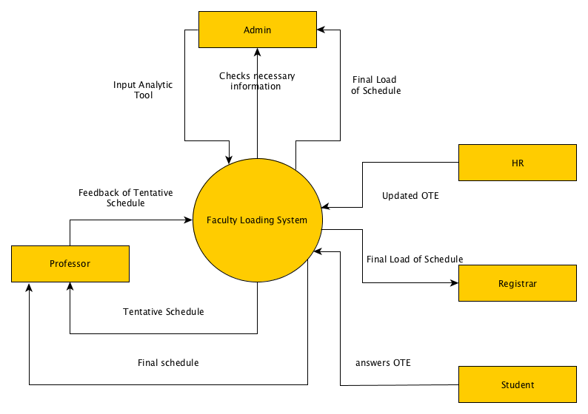

Figure 1: Context Diagram

1. Related Literature
2. Weidman, J.C. & May, D. C. (1994). *Implementing a faculty assessment system: a case study at the University of Pittsburgh USA.* UNESCO: International institute for educational planning.

According to a study written by John C. Weidman and Daniel C. May, “*Implementing a Faculty Assessment System”*, at the University of Pittsburgh, preparing educational leaders and administrators in their respective specialties and environment was a step in maintaining and improving the overall performance of the school. There was an assumption that the funding for the university was likely to increase at a relatively low rate, if at all, and that there would be no significant increase in total student enrolment. This means that the grand performance of the school is maintained, but not improved. To make the school’s performance increase and have a high level of quality education, they would develop a plan for internal reallocation of limited resources to improve performance in already strong units as well as to enable investments in units with particularly strong promises of reaching excellence.

By relating this study to our proposed project, we not only target fast and appropriate assignment of professors to their respective courses and subjects, we also target quality education for the students to improve their performance in academics and social needs. Not only that, this may also improve the rate of funding of the school, increase of total student enrolment, and the overall performance of the school. Reaching excellence is one of the key targets of this system.

1. Dibon. (2010). *Online-based instructors scheduling system.*

According to it, there is a high impact of workload on teachers and students. This problem results to unprepared classes, lack of time to assess to student works, negative impact on interacting with their students and unavailability on providing tutorials. To resolve this problem, they came up of having a Scheduling System that will organize the schedules of their teachers and students. They provide useful hypothesis and helpful suggestions for the innovation of the Scheduling System. It has been indicated that the Scheduling System must be good in data handling, security, scheduling, stability adaptability and accuracy. An organized schedule would result to much more positive outcome when it comes on the work and profession of the teachers and students.

1. Chantrapornchai, C. (2012, September). *Development of a faculty work load system: a case study in a public university.*

According to a study from Thailand, which was written by Chantana Chantrapornchai, entitled “Development of a faculty work load system: a case study in a public university”, states that there are different ways to assign the work of a faculty member and to evaluate the performance of a faculty member. In public universities in Thailand, their faculty members are mostly composed on government officials. Their evaluation is not really that important since it has a small effect on the salary. In order to help identify workload of a faculty member, an information system is needed. However, in the university, there were information systems that exist. Some of them are in papers and some are in computers. In this work, we develop an extended system to the existing ones. The system needs to aid the workload calculation per department in the university.